Chapter 9, Solution 58.

Using Fig. 9.65, design a problem to help other students to better understand impedance combinations.

Although there are many ways to work this problem, this is an example based on the same kind of problem asked in the third edition.

Problem

At ω = 50 rad/s, determine Z_{in} for each of the circuits in Fig. 9.65.

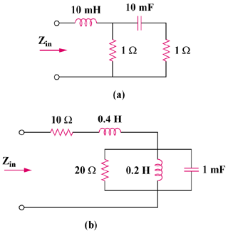

Figure 9.65

Solution

- 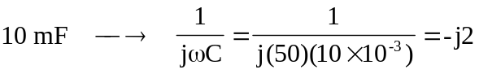

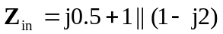
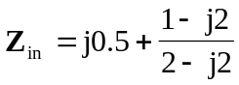
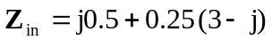
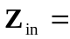 0.75 + j0.25 

- 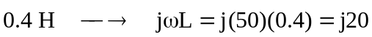
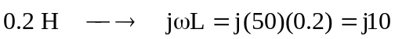
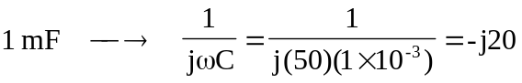

For the parallel elements,
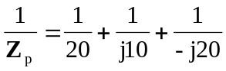
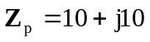
Then,
10 + j20 +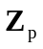 = 20 + j30 

